Project Design Phase

1. Introduction
The Project Design Phase focuses on designing the structure and working process of the Script-Controlled ACL. The design defines how the system checks the user's permission and the field value of a record before allowing or denying access.

2. Objectives
- To design the structure of the access-control system.
- To define the ACL logic for checking field values.
- To design the flow between the user, ACL, record, and database.
- To ensure secure and controlled record access.
- To prepare the design for implementation in ServiceNow.

3. Activities Performed
- Designed the overall access-control workflow.
- Identified the required table and field.
- Designed the Script-Controlled ACL logic.
- Defined the conditions for Allow Access and Deny Access.
- Designed the interaction between users, records, ACL, and database.
- Prepared the DFD for the proposed system.

4. Expected / Produced Output
- System design for the Script-Controlled ACL.
- Defined ACL access-control logic.
- Designed record and field validation flow.
- Defined allow/deny access conditions.
- Completed DFD representing the system design.

Screenshot

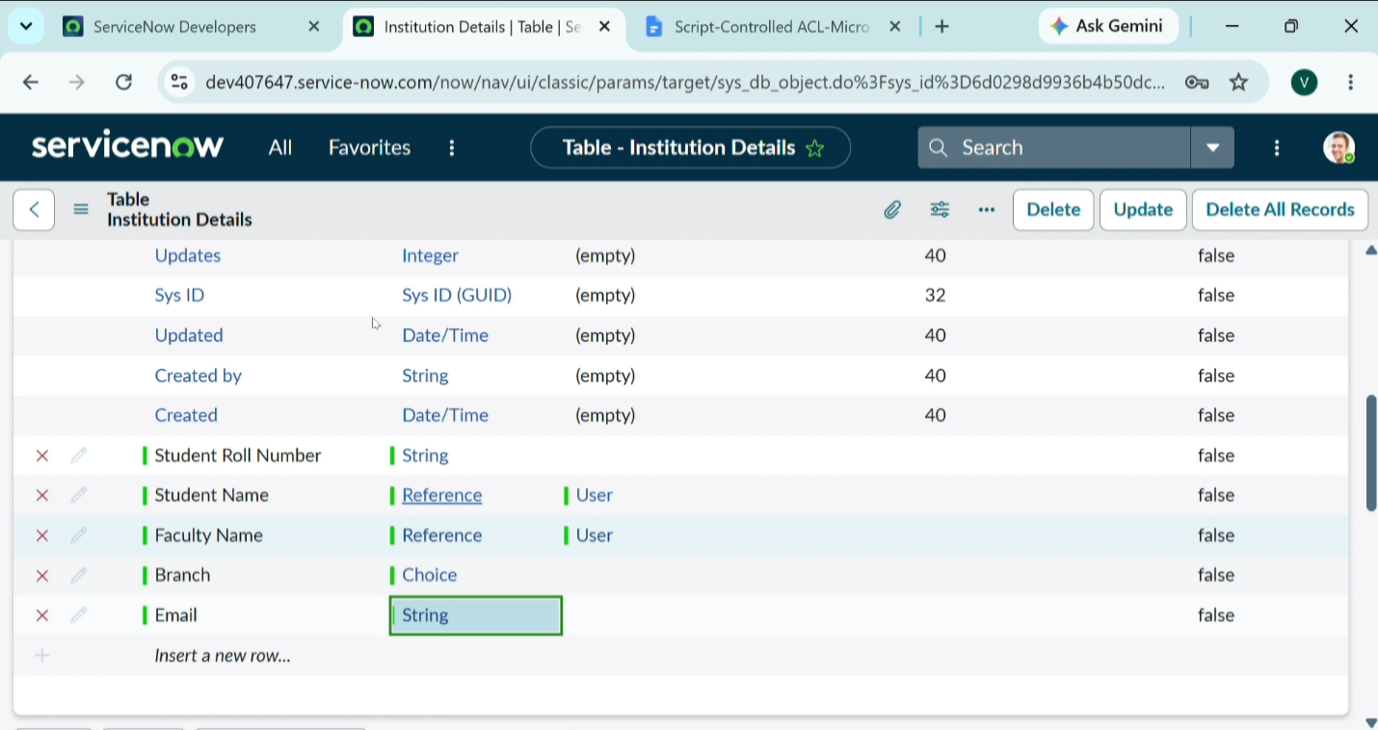

5. DFD – Project Design Phase
